Project Design Phase-II
Data Flow Diagram & User Stories

Date | 30 March 2026
Project Name | Video Conferencing App

Data Flow Diagrams:
A Data Flow Diagram (DFD) is a traditional visual representation of the information flows within a system. A neat and clear DFD can depict the right amount of the system requirement graphically. It shows how data enters and leaves the system, what changes the information, and where data is stored.
DFD Level 0:
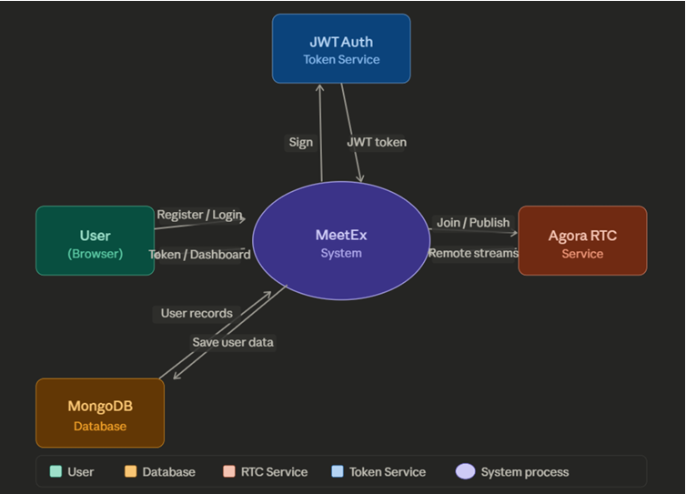
The four external entities and their data flows are:
- User (Browser) — sends registration/login credentials and meeting room names into the system; receives back authentication tokens, the dashboard, and live video feeds.
- JWT Token Service — receives token-signing requests from the system after a successful login; returns a signed JWT back to MeetEx for session management.
- MongoDB Database — receives user data (name, email, bcrypt-hashed password) for storage; returns stored user records during login verification.
- Agora RTC Service — receives channel join requests and published audio/video streams from the system; returns remote participant streams that are displayed in the meeting room grid.

